Internship Report

Intern: Syed Shabih Haider Zaidi
Department: IT
Duration: August 2026 – September 2026
Position: IT Intern
Institution: BS Artificial Intelligence, 4th Semester, UMT
Supervisor: Sir Adeel

1. Introduction

I am a fourth-semester BS Artificial Intelligence student. When I received the referral for an internship at Highnoon Laboratories Ltd., I was a mix of nervous and excited. This was going to be my first real experience in a professional software development environment.
To be honest, my coding skills weren't where I wanted them to be. I knew databases well, but I had only studied Node.js without gaining real command over it. Everything else — TypeScript, Express, React, AI integration — was new territory for me. I didn't know what to expect. I just knew I wanted to learn.

This report documents my internship experience from August 2026 to September 2026. It covers the technical work I completed, the challenges I faced, the skills I acquired, and my personal growth. It is honest — including the frustrating moments, the boring days, and the mistakes I made, because those are just as much a part of the learning experience as the successes.
My internship focused on building an AI-powered Campus Assistant application. This involved setting up a professional development environment, learning TypeScript fundamentals, building a REST API with Express.js, designing a PostgreSQL database with Prisma ORM, implementing authentication, refactoring to Clean Architecture, integrating AI chatbot capabilities using LLM APIs, developing a Retrieval-Augmented Generation pipeline, and building a voice-to-voice AI assistant.

2. Company Overview & Work Environment

2.1 About Highnoon Laboratories Ltd.
Highnoon Laboratories Ltd. is a pharmaceutical company based in Lahore, Pakistan. My internship was in the AI and Software Development department, where I worked on building intelligent applications to assist students and faculty.

2.2 First Impressions
From Day 1, the environment was welcoming. I was nervous, but that fear quickly disappeared. Everyone was supportive, patient, and genuinely willing to help. No one made me feel like I was asking a stupid question. The office had a collaborative and relaxed atmosphere. We worked hard, but there was always time for tea breaks and casual conversation.

2.3 Work Schedule
The work schedule was on-site, 9:00 AM to 5:30 PM, Monday through Friday. A typical day involved arriving in the morning, reviewing my task roadmap, and diving into code. Postman was always open in one tab, PostgreSQL in another, and Prisma documentation in a third. The tea breaks with Hassan were sacred. They weren't just about caffeine. They were about decompressing and talking through problems.

2.4 The People Who Shaped My Experience
Sir Adeel was my primary mentor, overseeing my AI-based work and overall progress. In our very first meeting, he was trying to figure out what we knew so he could assign tasks properly. But his impact went beyond technical mentorship. He said something that stayed with me: "This is a point in your lives where you decide what to do with it and in the future."

That conversation set the tone for my entire internship. It wasn't just about code. It was about recognizing that this was a moment to decide who I wanted to become.
Sir Asad also provided guidance, particularly on database-related tasks.
Hassan, my fellow intern, was the biggest relief of my internship. We already knew each other from university, so there was no awkward getting-to-know-you phase. We just clicked into work mode. We had tea breaks together, ate lunch together, and when one of us was stuck, the other was right there. Having Hassan there made the internship not just bearable, but genuinely enjoyable.

2.5 Tools and Technologies
Throughout my internship, I used VS Code as my code editor, PostgreSQL and Prisma ORM for the database, Postman for API testing, Git and GitHub for version control, Node.js as the runtime, TypeScript as my primary language, React and Vite for the frontend, and Groq and Google Gemini for AI APIs.

3. Internship Objectives and Roadmap

My internship followed a detailed roadmap spanning multiple modules, taking me from fundamental concepts to advanced AI integration. The goal was to build a complete AI-powered Campus Assistant.

Module 1.1: Development Environment Setup — Complete
Module 1.2: Git Workflow — Complete
Module 2.1: TypeScript Fundamentals — Complete
Module 3.1: REST API Development — Complete
Module 4.1: Database Design — Complete
Module 5.1: Authentication — Complete
Module 6.1: Service Architecture — Complete
Module 7.1: AI Chatbot — Complete
Module 7.2: Prompt Engineering — Complete
Module 7.3: Conversation Memory — Partial
Module 7.4: Document Chat (RAG) — Partial
Module 7.5: Voice Assistant — Partial

4. Module 1: Development Environment and Git Workflow

I began by installing Node.js LTS, confirming npm worked, and setting up TypeScript with a proper tsconfig.json. I configured Git with my name and email, created a GitHub repository with a README, and set up ESLint and Prettier for code quality. I also installed Postman for API testing and added VS Code extensions like ESLint, Prettier, and GitLens.

For Git workflow, I learned to clone repositories, create feature branches, make atomic commits with clear messages, push branches to remote, open pull requests with descriptions, merge PRs after self-review, and resolve merge conflicts. This was my first exposure to a professional Git workflow.
The Wrong Branch Mistake: I accidentally pushed my work to an entirely non-existent branch and didn't realize it until much later. When I finally figured it out, I was shocked in a funny way. Like, how did I even do that? But I fixed it. Lesson learned: always check Git status and branch list before pushing.
Key Learnings: Professional Git workflow is essential for collaboration. Atomic commits make debugging easier. Always verify your branch before pushing.

5. Module 2: TypeScript Fundamentals

This module solidified my TypeScript foundation. I created a Student class implementing an interface, used union types for fixed values like Active or Inactive, and built a reusable generic Repository class that worked for both students and courses. I also implemented async/await patterns with a simulated API, added input validation with clear error messages, built a CLI menu for CRUD operations, and compiled clean in strict mode.

Key Learnings: TypeScript's type system prevents bugs before they occur. Generics enable powerful code reuse. Strict mode catches issues early.

6. Module 3: REST API Development

I built a complete REST API using Express.js and TypeScript. This included a POST endpoint for creating students returning 201, GET endpoints for all students and single students returning 200 or 404, PUT and PATCH endpoints for updates, and a DELETE endpoint returning 200 with deleted info. I added request validation using Zod, a centralized error handler that returned clean JSON, and logging middleware that tracked every request.
Key Learnings: REST APIs follow predictable patterns. Validation prevents bad data. Centralized error handling makes APIs more robust. Logging is essential for debugging.

7. Module 4: Database Design and Integration

This was my favorite module. I designed an ERD for a university management system with entities for Students, Teachers, Courses, Enrollment, and Results. I created tables with primary and foreign key relationships, applied constraints like NOT NULL and UNIQUE, set up migrations using Prisma, wrote a seed script to populate the database with sample data, and connected the API to the database using Prisma Client.

Key Learnings: Database design is about relationships. Foreign keys enforce data integrity. Migrations allow schema evolution. Seed scripts make testing easier.
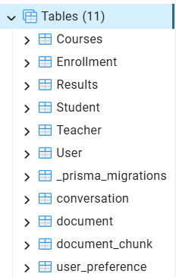

8. Module 5: Authentication and Security

I built a full authentication system. This included a register endpoint with email validation, password hashing with bcrypt, login returning JWT tokens, authentication middleware protecting routes, role-based access control where only admins could delete students, and token expiry handling. I also saved auth flows in Postman.
Key Learnings: Authentication verifies identity. Authorization controls access. Password hashing is non-negotiable. JWT tokens enable stateless authentication.

9. Module 6: Service Architecture (Clean Architecture)

I refactored the entire application to follow Clean Architecture principles. Controllers handled HTTP only, services contained business logic, repositories handled data access, and DTOs defined the shape of data between layers. I kept dependency flow one-directional from Controller to Service to Repository to Prisma ORM with no circular imports, and documented the folder structure in the README.
Key Learnings: Clean Architecture separates concerns. Layered architecture makes code testable. One-directional flow prevents circular dependencies.

10. Module 7.1: AI Chatbot Development

I built a POST /chat endpoint that communicated with an LLM via the Groq API. The chatbot stored conversations in the database, supported multi-turn conversation, handled loading states with a pending indicator, handled API failures gracefully with friendly error messages, and included a rate limiter to prevent spam.
Key Learnings: LLM APIs are powerful but need careful error handling. Environment variables protect secrets. Rate limiting prevents abuse.

11. Module 7.2: Prompt Engineering

I developed a sophisticated system prompt through multiple iterations. The first iteration was naive with just "You are a helpful assistant" and gave generic answers. The second was domain-scoped but still answered off-topic questions. The final version included scope, tone, strict refusal guidelines, and few-shot examples. I stored the final prompt in a config file, not scattered strings.
Key Learnings: Prompt engineering is creative and technical. Iteration improves results. Constraints keep the bot on track.

12. Module 7.3: Conversation Memory (Partial)

I persisted messages per conversation, injected a history window into the prompt so the bot could answer follow-up questions, implemented truncation of old messages to stay under token limits, and stored user preferences like preferred language in the database.
Key Learnings: Conversation memory requires storage and retrieval. History windows balance context and token limits.

13. Module 7.4: Document Chat (RAG) – Partial

I built a file upload endpoint for PDFs, extracted text using pdf-parse, implemented a chunking strategy, generated embeddings, and implemented similarity search.
The Chunking Problem: This was the hardest part of the internship. The text kept getting cut off from the start or end, like "occasion" becoming "ssion." It was frustrating, and I spent an absurd amount of time on it. But I kept going, and eventually got it working.
Key Learnings: RAG requires careful chunking. Chunking is harder than it looks. Persistence pays off.

14. Module 7.5: Voice Assistant – Partial

I built a voice-to-voice interaction loop: audio upload, speech-to-text using Groq's Whisper model, routing the transcript through the chatbot pipeline, and returning a text-to-speech audio reply using a local gtts library.
The "Aha!" Moment: When I heard the voice assistant respond to my question for the first time, when the entire round-trip finally worked, I was ecstatic. Hassan saw my reaction because he'd already been through that process himself. It was real excitement. Pure joy. That was my aha moment. It was proof that I could build something complex and real.
Key Learnings: Voice interfaces are complex but rewarding. The aha moment makes all the struggle worth it.

15. Challenges and How I Overcame Them

The Chunking Problem: I could not get chunking right. The text kept getting cut off. I kept going, read documentation, experimented, and eventually got it working. Patience was key.
The Groq API Key Errors: The API key kept giving errors because the format didn't work in our VS Code environment. I checked documentation carefully and eventually found the right syntax.
The Wrong Branch Push: I accidentally pushed my work to a non-existent branch. I fixed it and learned to always check Git status before pushing.
The Document Comparator: I worked on a document comparator for two days and it was rough. I genuinely questioned if I belonged there. Imposter syndrome hit hard. But I pushed through it, partly because Hassan was there, partly because I didn't want to give up.
Feeling Stuck: I felt stuck many times. I asked Sir Adeel or Hassan for help, and I took a step back to read errors carefully. I learned that asking for help is not a sign of weakness. It's a sign of maturity.

16. Key Technical Skills Acquired

Technical: TypeScript, JavaScript, Node.js, Express.js, REST APIs, PostgreSQL, Prisma ORM, SQL, React, Vite, JWT, bcrypt, Clean Architecture, LLM APIs like Groq, Prompt Engineering, RAG pipelines, Embeddings, Git, GitHub, ESLint, Prettier.
Professional: Git workflow, code review, debugging strategies, API testing with Postman, documentation, asking for help effectively.
Personal: Patience, calmness under pressure, self-awareness, persistence, communication.
What I Learned That I Didn't Expect: Patience. I went into this internship thinking it would be about writing code quickly. I came out realizing that the real skill is in debugging, in staring at an error for 30 minutes and not giving up. I also learned I can now give effective prompts, which is a skill I didn't even know I needed.

17. Personal Growth and Reflection

How I've Changed: I look back at the version of myself who started this internship, nervous and unsure of my TypeScript skills, and I feel good about the way I’ve changed. I can now structure a full-stack application using Clean Architecture, integrate AI features into a production application, write effective prompts for LLMs, debug issues across multiple layers, and navigate a codebase with confidence.
What I'm Proud Of: The AI chatbot project. I designed it, built it, debugged it, and watched it come to life. It's proof that I can take an idea and make it real. I'm also proud of the UI I built for my AI bot. I added two themes specifically for people with albinism and people with low vision. That was a personal touch.
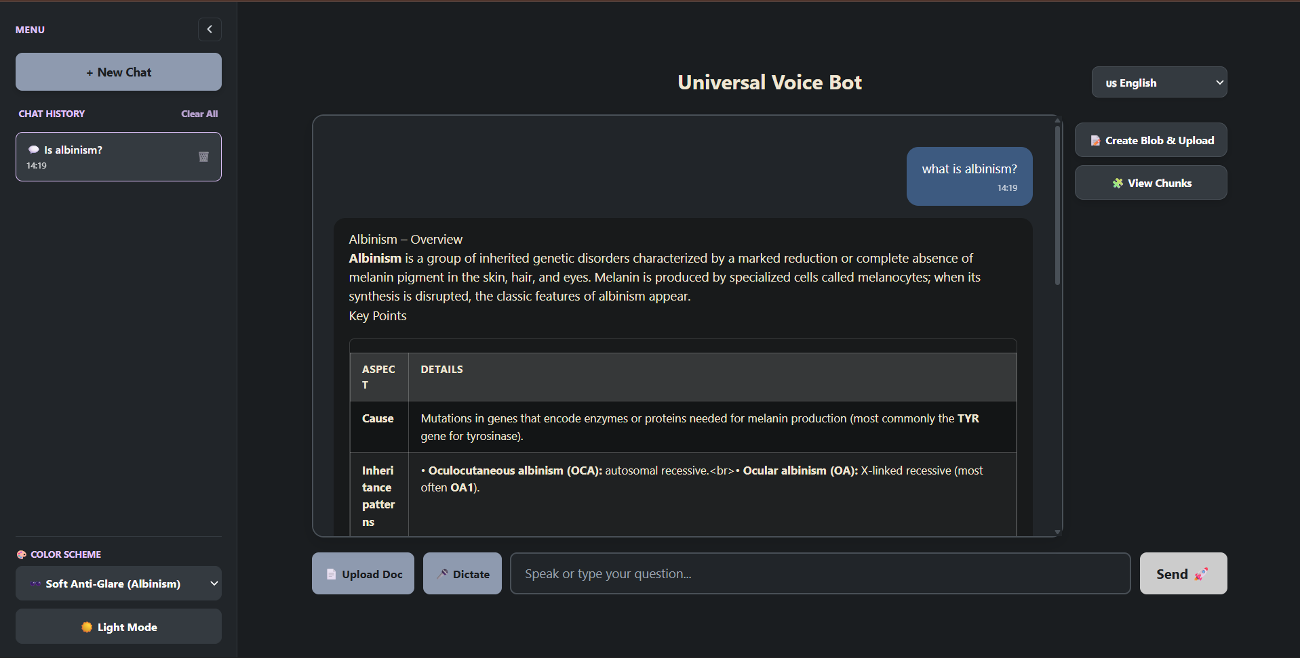
What I Would Do Differently: I would be calmer. I panicked a lot in the beginning. I overthought problems and stressed about things that, in hindsight, were small. I would also ask for help sooner and document as I go.
What's Next: I want to improve my TypeScript skills further and explore more advanced AI concepts. This internship has shown me that I have a genuine passion for building intelligent systems.
How I Felt at the End: Sad, but in a good way. I learned a bunch of stuff, had a good time, and made something I'm proud of.

18. Conclusion and Acknowledgments

Would I recommend this internship to other students? Absolutely. It gave me a realistic, hands-on understanding of what it means to work in a professional software environment. I didn't just learn new technologies. I learned how to think like a developer. I learned how to be patient, how to ask for help, how to debug effectively, and how to navigate a codebase with confidence.
I walked into Highnoon nervous and unsure. I walked out with a portfolio project I'm proud of, a set of skills I didn't have before, and a clearer sense of who I want to be as an engineer.
To Sir Adeel, Sir Asad, and Hassan, thank you. This was the start of something, and I couldn't have asked for a better place to begin.

Key Features Implemented:
Student CRUD API
User authentication with register and login
JWT-based authorization
Role-based access control
AI chatbot integration
Prompt engineering
Conversation memory (partial)
PDF upload and text extraction (partial)
Voice assistant (partial)

Tools Used:
VS Code as Code editor
PostgreSQL as Database
Prisma as ORM
Postman for API testing
Git for Version control
GitHub as Remote repository
Groq as LLM API
Node.js as Runtime
React as Frontend

